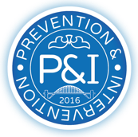

Behaviour Support Programme Agreement 2024/25
Please note if you currently have a behaviour bolt-on with Clennell Education please do not attempt to purchase this service firm the P&I training website. Please purchase through Clennell Education Solutions directly to receive your 50% cost reduction. This agreement will automatically be renewed at the same level each year unless we have received a Change to Service Level Agreement or opt out form at least two weeks prior to your new contract starting. If this isn’t received charges may occur. The price will not increase without prior notice, however we reserve the right to amend our overall offer.
Behaviour Support Programme Purchase Agreement 2024/25
I would like to purchase the behaviour support programme via invoice at a cost of £800
Please complete all fields and forward to admin@panditraining.co.uk
The date you would like your agreement to begin:
School Name:
School address:
Postcode:
Name of trust (if applicable)
Name and Position of person purchasing: | Name: | Position:
Signature: |  | Date signed
Email address:
Invoice address: (if different from above)
Invoice Post Code: (if different from above)
Invoice email address: (if different from above)

Email completed form to: admin@panditraining.co.uk

